**2020年1月浙江省高考英语试卷**

第一部分 听力（共两节, 满分30分）

做题时,先将答案标在试卷上。录音内容结束后,你将有两分钟的时间将试卷上的答案转涂到答题纸上。

第一节（共5小题; 每小题1.5分, 满分7.5分）

听下面5段对话。每段对话后有一个小题,从题中所给的A、B、C三个选项中选出最佳选

项,并标在试卷的相应位置。听完每段对话后,你都有10秒钟的时间来回答有关小题和阅读下一小题。每段对话仅读一遍。

1. Where does the conversation probably take place?

A. At a zoo.                       B. In a library.                          C. In a drugstore.

2. What will the man do next?

A. Change some money. B. Take the food home.          C. Sit and eat his meal.

3. What does the woman suggest?

A. Buying a computer             B. Hiring an assistant.             C. Starting a business.

4. What are the speakers talking about?

A. The weather.                B. The scenery.                  C. The traffic.

5. When did the man see the film?

A. On Wednesday.                  B. On Thursday.                C. On Saturday.

第二节（共15小题; 每小题1.5分, 满分22.5分）

听下面5段对话或独白每段对话或独白后有几个小题,从题中所给的A、B、C三个选项中选出最佳选项,并标在试卷的相应位置。听每段对话或独白前,你将有时间阅读各个小题, 每小题5秒钟;听完后,各小题将给出5秒钟的作答时间。每段对话或独白读两遍。

听第6段材料,回答第6、7题。

6. Who is the newcomer?

A. David Cook.                B. Joey Sanders.               C. Liam Neeson.

7. What is the newcomer’s position in the company?

A. He is a film director. B. He is a program manager. C. He is a department head.

听第7段材料,回答第8至10题。

8. What does the woman do?

A. She’s a secretary.         B. She’s a hotel maid.             C. She’s a salesperson.

9. What is the man going to do?

A. Change the sheets.             B. Have breakfast.                  C. Meet his friends.

10. What does the man ask the woman to do at the end of the conversation?

A. Take the plate away. B. Bring some towels. C. Turn on the light.

听第8段材料,回答第11至13题。

11. Why does Jessica make the call?

A. To look for her passport. B. To apply for a credit card. C. To ask for the manager.

12. Where will Jessica go right after the phone call?

A. The bank.                           B. Her home.                            C. The supermarket.

13. How does the man sound?

A. Helpful.                       B. Nervous.                       C. Surprised.

听第9段材料,回答第14至17题。

14. What is the man doing?

A. Placing an order.         B. Selling insurance.               C. Conducting an interview.

15. What did Leaney study for a degree?

A. Finance.                       B. Education.                           C. Public Relations.

16. What is an advantage of a smaller business according to Leaney?

A. Greater contributions to the neighborhood.

B. Closer employer-employee relationship.

C. More flexibility in providing services.

17. What is Leaney’s plan for the next two weeks?

A. To visit her parents. B. To call her relatives. C. To finish her work.

听第10段材料,回答第18至20题。

18. What is the purpose of the talk?

A. To present a prize.              B. To introduce a lecturer.       C. To recommend book.

19. Where is Russel working now?

A. In Oxford.                          B. In Chicago.                          C. In Virginia.

20. What does Russel think of sleep?

A. It’s seldom studied. B. It’s just a waste of time. C. It’s of great importance.

第二部分阅读理解（共两节,满分35分）

第一节（共10小题;每小题2.5分,满分25分）

阅读下列短文,从每题所给的A、B、C和D四个选项中选出最佳选项,并在答题纸上将该项涂黑。

A

I never knew anyone who’d grown up in Jackson without being afraid of Mrs. Calloway, our librarian. She ran Jackson’s Carnegie Library absolutely by herself. SILENCE in big black letters was on signs hung everywhere If she thought you were dressed improperly, she sent you straight back home to change your clothes. I was willing; I would do anything to read.

My mother was not afraid of Mrs. Calloway She wished me to have my own library card to check out books for myself. She took me in to introduce me. “Eudora is nine years old and has my permission to read any book she wants from the shelves, children or adults,” Mother said.

Mrs. Calloway made her own rules about books. You could not take back a book to the library on the same day you’d taken it out; it made no difference to her that you’d read every word in it and needed another to start. You could take out two books at time and two only. So two by two,I read library books as fast as I could go: rushing them home in the basket of my bicycle. From the minute reached our house, I started to read. knew this was extreme happiness, knew it at the time.

My mother shared this feeling of mine. Now I think of her as reading so much of the time while doing something else. I remember her reading a magazine while taking the part of the Wolf in a game of “Little Red Riding Hood” with my brother’s two daughters. She’d just look up at the right time, long enough to answer-in character - “The better to eat you with, my dear,” and go back to her place in the magazine article.

21. Which of the following best describes Mrs. Calloway?

A. Quiet.                          B. Strict.                            C. Humorous.                    D. Considerate.

22. What do the underlined words “this feeling” refer to in the last paragraph?

A. Desire to read.                                                B. Love for Mrs. Calloway.

C. Interest in games.                                             D. Fear of the library rules.

23. Where is the text probably from?

A. A guidebook.                                                  B. An autobiography.

C. A news report.                                                D. A book review.

B

Milwaukee, Wisconsin, is road testing a new way to keep winter roads ice-free -by spreading on them cheese brine, the salty liquid used to make soft cheeses, like mozzarella.

Wisconsin, also called “America’s Dairyland,” is famous for its cheese. The state produced 2.8 billion pounds of cheese last year! As a result, there was a lot of leftover cheese brine. Disposing of（处置）the brine can be expensive. So what should cheese makers do with the waste?

Normally, towns use rock salt to de-ice streets. The salt lowers water’s freezing point, causing ice to melt（融化）. But using cheese brine could help both cheese producers and cities save money, while keeping roads safe Cheese brine has salt in it, which, like the rock salt, helps lower water’s freezing point.

In addition to saving money, cheese brine could also be a more eco-friendly option. Many people suspect that all the rock salt used every winter is harming the environment.

Rock salt is made of sodium chloride, the same compound（化合物）in ordinary table salt. Sounds harmless, right? But while you probably add only a small amount of salt to your food, road crews spread about 20 million tons of salt on U. S. roads every year！

The chemical washes off roads and goes into the ground. There it can pollute drinking water, harm plants, and eat away soil. By spreading cheese brine on streets before adding a layer of rock salt, Milwaukee may be able to cut its rock salt use by 30 percent.

Cheese brine has a downside too a smell similar to that of bad milk. “I don’t really mind it,” Emil Norby told Modern Farmer magazine. He works for one of Wisconsin’s county highway commissions and came up with the idea of using cheese brine. “Our roads smell like Wisconsin!” he said.

24. Why can cheese brine help keep winter roads ice-free?

A. It is soft.                                           B. It contains salt.

C. It is warm.                                        D. It has milk in it.

25. What is benefit of using cheese brine on roads?

A. Improving air quality.

B. Increasing sales of rock salt.

C. Reducing water pollution.

D. Saving the cheese industry.

26. Milwaukee’s new way to de-ice streets may be an example of __________.

A. barking up the wrong tree                B. putting the cart before the horse

C. robbing Peter to pay Paul                 D. killing two birds with one stone

C

Today’s world is not an easy adjustment for young adults. A key skill set for success is persistence （毅力）, characteristic that researchers say is heavily influenced by fathers. Researchers from Brigham Young University discovered that fathers are in a unique position to help their adolescent children learn persistence.

BYU professors Laura Padilla-Walker and Randal Day arrived at these findings after following 325 American families over several years. And over time, the persistence gained through fathers led to higher achievement in school.

“There are relatively few studies that stress the unique role of fathers,” Padilla-Walker said. “This research also helps to prove that characteristics such as persistence -- which can be taught -- are key to a child’s life success.”

Researchers determined that dads need to practice an “authoritative” parenting style. Authoritative parenting is not authoritarian: rigid, demanding or controlling. Rather, an authoritative parenting style includes some of the following characteristics: children feel warmth and love from their father; responsibility and the reasons behind rules are stressed; children are given an appropriate level of autonomy（自主权）.

In the study, about 52 percent of the dads exhibited above-average levels of authoritative parenting. key finding is that over time, children raised by an authoritative father were significantly more likely to develop persistence, which leads to better outcomes in school.

This particular study examined 11 to 14-year-olds living in two-parent homes. Yet the researchers suggest that single parents still may play a role in teaching the benefits of persistence, which is an avenue of future research.

27. What is special about the BYU professors’ study?

A. It centered on fathers’ role in parenting.

B. It was based on a number of large families.

C. It analyzed different kinds of parenting styles.

D. It aimed to improve kids’ achievement in school.

28. What would an authoritative father do when raising his children?

A. Ignore their demands.                             B. Make decisions for them.

C. Control their behaviors.                    D. Explain the rules to them.

29. Which group can be a focus of future studies according to the researchers?

A. Single parents.                                  B. Children aged from 11 to 14.

C. Authoritarian fathers.                       D. Mothers in two-parent homes.

30. Which of the following is the best title for the text?

A. Three Characteristics of Authoritative Fathers

B. Key Skills for Young Adults to Succeed in Future

C. Children Tend to Learn Determination from Father

D. Family Relationship Influences School Performance

**第二节（共5小题;每小题2分满分10分）**

根据短文内容,从短文后的选项中选出能填入空白处的最佳选项。选项中有两项为多余选项。

Let’s take a minute to think about the water we use. The human body is 60% water and we need to drink lots of water to be healthy When we are thirsty we just go to the kitchen and fill a glass with clean water.

**31** For example, farmers, who produce the food we eat, use water to make the plants grow. When we turn on a light or switch on a TV or a computer we use energy and we need water to produce this energy.

The truth is that we are lucky enough to have clean water whenever we want, but this is not the case for many people around the world. **32** That’s around one in 10 people in the world. If we drink dirty water, we can catch diseases from the bacteria and become ill. Every year over 500,000 children die from diarrhoea（腹泻） from dirty water. That’s around 1,400 children every day! Also, in some countries children walk many kilometres every day to get water. **33** Therefore, they don’t have time to learn how to read or write and don’t get an education.

**34** On this day every year, countries around the world hold events to educate people about the problems of dirty water and that clean water is something that everyone should have around the world. At one school in the UK, children between the ages of 10 and 15 walk 6km with six litres of water. **35** People give them money to do this and all the money helps get clean water to as many people as possible around the world.

A. We use water indirectly too.

 B. Every system in our body depends on water to function.

 C. It is to inspire people to learn more about water-related problems.

 D. If children walk many hours a day to get water: they can’t go to school.

 E. Did you know that around 750 million people do not have clean water to drink?

 F. In 1993 the United Nations decided that March 22nd is the World Day for Water.

 G. In this way, they know how it feels to walk a long distance carrying heavy bottles.

**第三部分** **语言运用（共两节,满分45分**

**第一节（共20小题;每小题1.5分,满分30分）**

阅读下面短文,从短文后各题所给的A、B、C和D四个选项中,选出可以填入空白处的最佳选项,并在答题纸上将该项涂黑。

I was born legally blind. Of all the stories of my early childhood, the one about a  36  is my mother’s favorite.

I was only two when the  37  occurred We had just arrived home from a trip. Mom lifted me out of the car and  38  to speak to the driver. I took advantage of my brief  39  to dash across the lawn（草坪） -- and hit large maple tree! I was running so fast that I bounced off the trunk and  40   on my backside. Mom  41  me to start crying, but I just sat there for a minute. Then I  42  myself up and kept right on going. Mom always  43  here that, as many times as I  44  across the lawn after that, I never again  45  into that tree.

Mom loves to use this story as an  46 . It reminds her that children don’t enter life  47  to take risks or unwilling to  48  again when they fall down. She never wanted me to lose that  49  as grew older. When  50  my major life decisions, was still that little girl tearing full-speed across the lawn. I studied abroad and later moved away from my parents’ home to look for  51  Through years of  52 , have become respected teacher in school serving high-need students.

We are almost certain to get  53  at some point during the process of achieving our goal. When that happens, don’t sit in the grass and  54  Just get up and keep on going. It will all be worth it  55 .

|  |  |  |  |
| --- | --- | --- | --- |
| 36. A. trip | B. race | C. tree | D. driver |
| 37. A. incident | B. change | C. illness | D. problem |
| 38. A. feared | B. refused | C. forgot | D. turned |
| 39. A. delay | B. absence | C. freedom | D. rest |
| 40. A. landed | B. slept | C. laughed | D. wept |
| 41. A. promised. | B. encouraged | C. allowed | D. expected |
| 42. A. woke | B. picked | C. warmed | D. gave |
| 43. A. adds | B. replies | C. admits | D. supposes |
| 44. A. drove | B. lived | C. stood | D. zoomed |
| 45. A. crashed | B. broke | C. climbed | D. looked |
| 46. A. answer | B. example | C. excuse | D. order |
| 47. A. able | B. ashamed | C. afraid | D. anxious |
| 48. A. ask | B. share | C. learn | D. try |
| 49. A. honesty | B. toughness | C. kindness | D. curiosity |
| 50. A. regretted | B. reviewed | C. made | D. explained |
| 51. A. job | B. friend | C. fortune | D. house |
| 52. A. memories | B. efforts | C. research | D. experience |
| 53. A. mixed up | B. fed up | C. knocked down | D. settled down |
| 54. A. play | B. relax | C. dream | D. cry |
| 55. A. all at once | B. in the end | C. in either case | D. as a result |

**第二节（共10小题;每小题1.5分,** **满分15分）**

阅读下面材料,在空白处填入适当的内容（个单词）或括号内单词的正确形式。

Something significant is happening to the world population it is aging. The median age of an American in 1950   56   （be） 30 -- today it is 41 and is expected   57   （increase） to 42 by 2050. For Japan, the   58   （number） are more striking -- 22 in 1950, 46 today and 53 in 2050. In 2015, one in 12 people around the world were over 65; by 2050, it will be one in six.

This aging of the population is driven   59   two factors. The first is declining birth rates, which means old generations are large   60   （compare） to younger generations, and so, on average, the population becomes   61   （old） than before. This is   62   （particular） true in the US. The second reason is that people are living longer. A child born in the US today has   63   very realistic chance of living beyond 100 and needs to plan accordingly.

People tend to focus on the first factor. However, greater attention should   64   （place） on longevity （长寿）. It isn’t just that people are, on average, living longer. It’s also that they are on average healthier   65   more productive for longer. Therefore, they can work for longer, consume more and in general be boost to the economy.

**第四部分** **写作（共两节,满分40分）**

**第一节** **应用文写作（满分15分）**

假定你是李华,你校将举办外国学生中文演讲比赛,请给你的英国朋友 George写封邮件

邀请他参加内容包括:

1.比赛时间; 2.演讲话题; 3.报名方式。

注意:1.词数80左右; 2.可适当增加细节,以使行文连贯

**第二节** **读后续写（满分25分）**

阅读下面短文,根据所给情节进行续写,使之构成一个完整的故事

“I’m going to miss you so much, Poppy,” said the tall, thin teenager. He bent down to hug his old friend goodbye. He stood up, hugged his parents, and smiled, trying not to let his emotions（情绪） get the better of him.

His parents were not quite able to keep theirs under control. They had driven their son several hours out of town to the university where he would soon be living and studying. It was time to say goodbye for now at least. The family hugged and smiled through misty eyes and then laughed.

The boy lifted the last bag onto his shoulder, and flashed a bright smile. “I guess this is it,” he said. “I’ll see you back home in a month, okay?” His parents nodded, and they watched as he walked out of sight into the crowds of hundreds of students and parents. The boy’s mother turned to the dog, “Okay, Poppy, time to go back home.”

The house seemed quiet as a tomb without the boy living there. All that week, Poppy didn’t seem interested in her dinner, her favorite toy, or even in her daily walk. Her owners were sad too, but they knew their son would be back to visit. Poppy didn’t.

They offered the dog some of her favorite peanut butter treats. They even let her sit on the sofa, but the old girl just wasn’t her usual cheerful self. Her owners started to get worried. “What should we do to cheer Poppy up?” asked Dad. “We’ve tried everything.”

“I have an idea, but it might be a little crazy,” smiled Mom. “Without anybody left in the house but us, this place could use a bit of fun. Let’s get a little dog for Poppy.

It didn’t take long before they walked through the front door carrying a big box. Poppy welcomed them home as usual but when she saw the box, she stopped. She put her nose on it. Her tail began wagging（摆动）ever so slowly, then faster as she caught the smell.

注意:

1. 所续写短文的词数应为150左右;

2. 至少使用5个短文中标有下划线的关键词语;

3. 续写部分分为两段, 每段的开头语已为你写好;

4. 续写完成后, 请用下划线标出你所使用的关键词语。

*Para* *1. Dad opened the box and a sweet little dog appeared.*

*Para* *2. A few weeks later, the boy arrived home from university.*

**2020年1月浙江省高考英语卷参考答案**

**第一部分听力**

1.B       2.C       3.B       4.A       5.B       6.B       7.C        8.B        9.C       10.A

11.A      12.B     13.A     14.C     15.A     16.C     17.A     18.B     19.A     20.C

**第二部分阅读理解**

21.B      22.A      23.B      24.B      25.C      26.D      27.A      28.D      29.A      30.C

31.A      32.E       33.D      34.F       35.G

**第三部分语言运用**

36.C      37.A      38.D      39.C      40.A

41.D      42.B      43.A      44.D      45.A

46.B      47.C      48.D      49.B      50.C

51.A      52.B      53.C      54.D      55.B

56. was               57. to increase            58. numbers         59. by                 60. compared

61.older               62. particularly           63. a                    64. be placed       65.and

第四部分写作

应用文

Dear George,

I’m writing to invite you to join us in the “Chinese speech contest for foreigners” to be held in our school. The activity is scheduled at 8:00 a.m. on January 20th in the lecture hall.

The theme of the speech contest is “differences between eastern and western customs”, **through which the foreign students are bound to gain a better understanding of Chinese splendid traditional culture and meanwhile strengthen their love of China.**

**Immensely fascinated by its mysterious culture and age-old history,** you can, undoubtedly give us a wonderful and impressive performance. You are expected to sign up for the contest at www.YSCOLLEGE.com. I’d appreciate it if you could accept our invitation.

Yours sincerely,

Li Hua

读后续写

***Dad opened the box and a sweet little dog appeared.*** Poppy jumped with joy at the sight of the little dog. She lowered her head to watch it curiously. Then she became so excited that she accidentally knocked over the box in an attempt to get closer. With the box tipping over, out came the little one, who was not shy and instantly got familiar with Poppy. It didn’t take long before the two played around the house, cheerfully running after each other.

***A few weeks later, the boy arrived home from the university.*** *He had been missing his parents and the dog since it was the first time that he had been away from home for such a long time. When the boy caught sight of Poppy, he went rushing toward the dog and bent down to give her a big hug. Suddenly, the boy noticed the little dog. “oh my dog, who is this?” his parents laughed at the look of surprise on his face. “it’s Poppy’s new companion.” Said mom.*

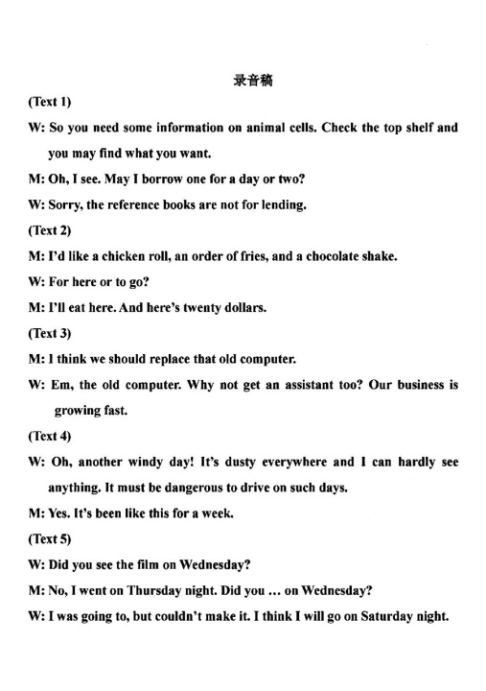

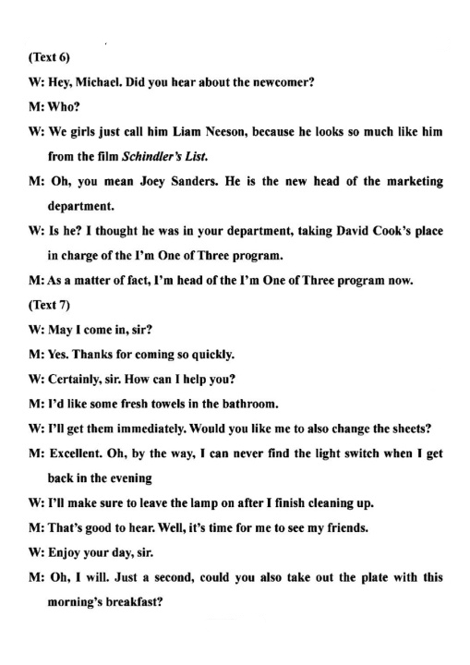

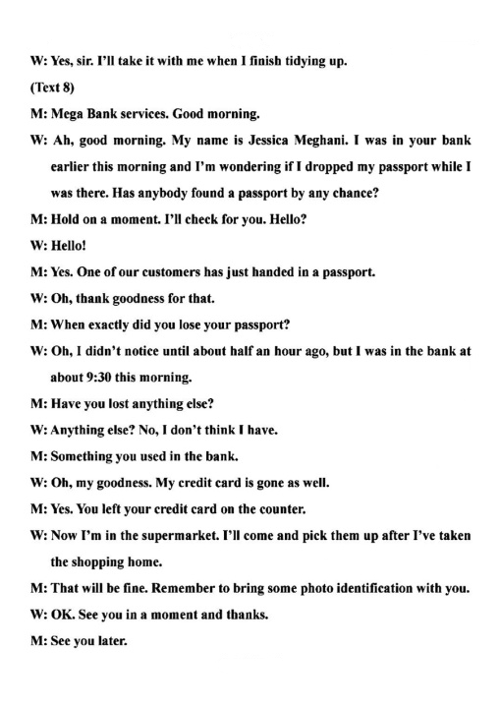

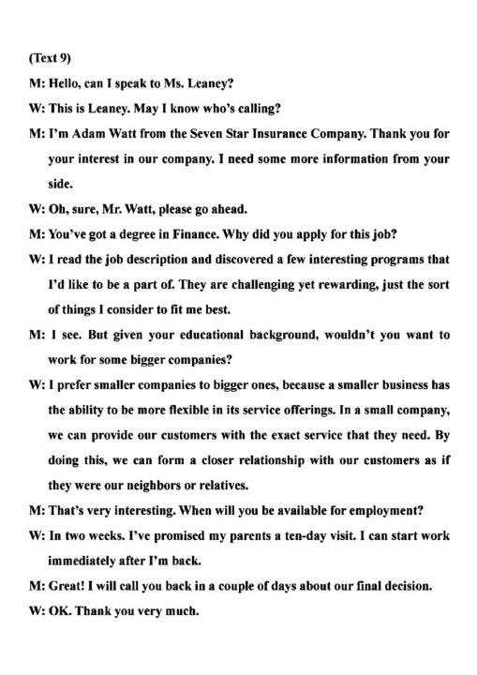

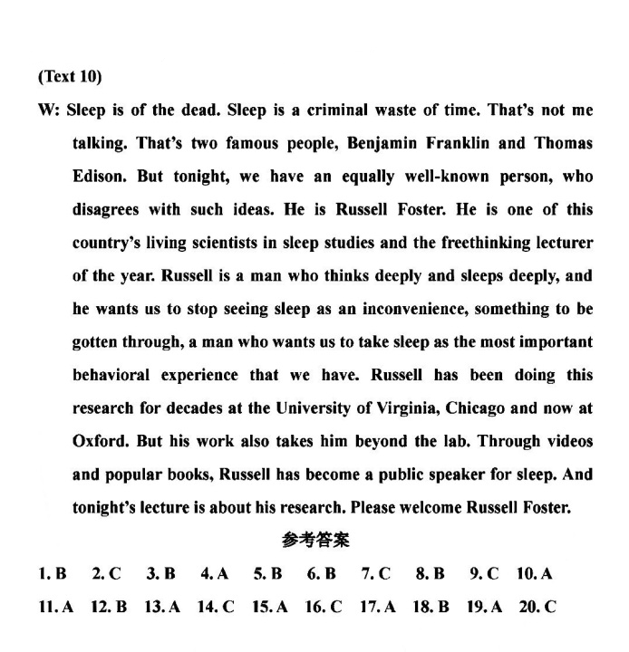

**阅读理解**

记叙文：描述作者回忆童年热爱阅读，去图书馆借书经历，描述了两个性格截然不同的人：严格的图书馆管理员和随和并热爱阅读的母亲

1. 选B，属于细节理解题。文章开头第一句就描述了孩子们都非常害怕图书馆管理员及经营者Mrs Calloway. 随后第一段的2,3句话就具体描述了她管理的图书馆的严谨和严格性：SILENCE in big black letters was on signs hung everywhere If she thought you were dressed improperly, she sent you straight back home to change your clothes.这句话极好地体现了Mrs Calloway的严厉性。文章第三段更是详细描述了她对图书馆借书还书的严格规则，也同样体现了她的严格。
2. 选A,属于猜词题中的代词指代题。划线词（this feeling）出现在最后一段第一行，这句话的意思是：我母亲和我有同样的感觉。那我这个感觉是什么呢？根据代词指代常识，我们从此处往前寻找答案线索，作者在上一段描述了自己迫不及待的阅读书的情景。From the minute I reached our house, I started to read. I knew this was **extreme happiness**, knew it at the time.而后，作者也描述了母亲也很爱读书。所以这种感觉应该是想阅读的那种感觉。
3. 选B,属于推理理解题。这篇文章实际上描述了作者童年热爱阅读的故事，当中涉及了母亲和图书馆管理员的情节，第一人称叙述，可以推理这是记录自己的故事的文章，因此属于自传（autobiogrphy）。其他选项A是旅游指南，参考手册 C是新闻报道 D是书评,显然不对。

这道题的B选项autobiogrphy，有些考生可能不知，实际上也可以通过排除法作出，其他三个选项都明显不对，单从体裁上就明显不符。

新闻报道类文章，介绍了奶酪盐水，废物利用，马路除冰，一举多得。

1. 选B,细节理解题。文章第三段The salt lowers water’s freezing point, causing ice to melt（融化）.Cheese brine has salt in it, which, like the rock salt, helps lower water’s freezing point.这两句话表明，奶酪盐水可以降低谁的冰点，从而达到马路除冰的效果。
2. 选C,细节理解题。文章第四段第一句In addition to saving money, cheese brine could also be a more eco-friendly option. 除了省钱，奶酪盐水还是个环保的选择，第四段具体解释了如何用奶酪盐水减少水污染。
3. 选D,推理理解题。这个题的主要难度在于四个选项的意思有些考生不理解。四个选项都属于谚语类型。A barking up the wrong tree攻击错了目标；白费力气；找错对象了。B.putting the cart before the horse本末倒置 C.robbing Peter to pay Paul拆 东 墙 补 西 墙 D killing two birds with one stone一石二鸟，一箭双雕。 基于文章中提到奶酪盐水马路除冰的众多好处，属于废物再利用了，省钱而且环保，这是一举两得的事情了。

研究类文章，介绍了父亲在培养孩子毅力方面的独特作用。

1. 选A，属于主旨归纳题。实际上问的是BYU教授团队这个研究主要研究什么？这个非常明显，第一段最后一句总起强调了父亲在孩子学习坚持和毅力方面的独特作用。Researchers from Brigham Young University discovered that fathers are in a unique position to help their adolescent children learn persistence.
2. 选D，理解推理题。文章第四段提到权威性父亲养育范式三个特点：孩子感受得到来自父亲的温暖和爱；规则后的责任和理由和孩子讲明白；孩子拥有一定的自主权。同一段另一句也强调了权威性养育范式不是呆板的严苛，不是控制。Authoritative parenting is not authoritarian: rigid, demanding or controlling. 所以这个题选择D，就是父亲会和孩子解释规则及规则后的缘由。
3. 选A,细节理解题.文章最后一段Yet the researchers suggest that single parents still may play a role in teaching the benefits of persistence, **which is an avenue of future research.**说明未来研究的重点可能是单亲父母这个群体的孩子养育问题。
4. 选C 主旨归纳题。文章开头就说了孩子的毅力很受父亲的影响。其他几个选项A 权威性父亲的三个特征，这只是文章第四段中的一个内容，不能代表全文，选它既是以偏概全了。B年轻人未来成功的技巧，这个虽然开头提了下，但是只是用来引入主题的，后面文章和这个话题几乎无关了。D家庭关系影响孩子在校成绩，这个话题和文章关系不大，属于偏了。文章强调父亲在培养孩子毅力方面的作用。

**七选五**

31 位置在段首，应该是总括全段，而后面紧跟for example表明后面是举例说明31的这个空的这句话。看了后面发现，它在说我们不仅直接用水，还要见解用水资源。所以选择A

32段中的位置，前后句中找信息。前一句说并非所有人都很幸运有水资源，世界上有很多地方缺乏水资源，后一句说这是十分之一的世界人口，那么中间一句肯定是讲世界上多少人缺水资源。因此选择E

33段中的位置，前后句中找线索，前一句说有些国家孩子要走还多路去取水，后一句说因此，他们没有时间去学校接受教育，那么中间肯定说，如果孩子们要耗时间取水的话，那没时间去上学了。因此选择D

34 位子在段首，紧跟的一句说On this way，...从这句话可以知道按某一种方式做事情，所以34肯定是一个具体行为，选项中F符合要求。

1. 根据前后都说英国的这个学校为了教育孩子明白长距离取水的不容易，采取了让孩子感受长距离取水的艰辛，所以35空应该是G

**完型填空**

1. C虽然是第一空，但是要从后文的作者撞树时间得知，这里说母亲最喜欢提起的事情是那棵树的事情。
2. A 后面描述的是作者小时候的一件撞树后的事件，所以这里用incident事件，小事的意思。
3. D母亲将我扶下车（lift）后，转头和司机说话。所以用turn to speak
4. C 这个题目对brief的理解，这里是简短的意思，意思是作者趁着这间隙（母亲和司机讲话）想迅速冲过草坪。所以，freedom，表示短暂的自由，因为平时总有母亲管着，这个时候母亲在和司机讲话。
5. A land是从空中落下的意思，作者因为跑太快，撞树后，弹出去后仰倒落在草坪上（bounced off the trunk and landed on my backside）
6. D 母亲看到孩子撞树摔倒，肯定以为（expect）孩子会哭
7. B 固定搭配，pick oneself up表示 摔倒后站起身来
8. A add是补充说的意思，每每母亲提到这件事，必然会补充说，自那以后，作者再也没有跑过草坪中撞到树了。
9. D 与前面dash呼应，应该是冲过草坪的意思，这个中zoom是嗖的一下，很快的意思。
10. A 与前面hit呼应，这里是crash，表示撞上的意思。
11. B 母亲将这个事件作为一个例子，教育作者要勇于尝试，不怕困难。
12. C 从后文or unwilling to...说明or前面填的是类似于不愿意，不敢的意思，所以选C
13. D 不敢或者不愿尝试在摔倒（失败）之后
14. B 母亲希望作者像小女孩时候的那样勇敢坚韧（toughness）的精神，不会因为撞树而放弃.
15. C 固定搭配，make the decision
16. A 毕业后，找工作（job）
17. B 经过多年的努力（efforts）,我成为了一个受人敬仰的老师
18. C Knock down撞到，打到之意. 在追求梦想的路上，总会遇到困难的。A mixed up混合，B fed up厌倦， D settle down 安顿下来，定居 都不符合上下文情景。
19. D 这里呼应作者小时候的表现，强调遇到困难(get knocked down)，不要坐着哭(cry)，而是要学着站起来。
20. B 作者强调这样的坚强精神终将（in the end）有回报。

**语法填空**

1. was 时间状语in 1950表示用过去式was
2. to increase 固定搭配 be expected to do
3. numbers 空格后面有are，说明是复数，所以用numbers
4. by 固定搭配或者理解为被动 be driven by受...驱动
5. Compared 和...相比 compared to， 这里注意compare这个词作状语时，一律用ed 形式
6. older 后面than 作为提示词，所以填older
7. particularly 修饰后面的true，修饰形容词要用副词，填particularly
8. a 表示有机会活到100岁开外，所以have a chance of ...
9. be placed 被动great attention should be placed on ...表示应该重视...
10. And 两个比较级中间用and连接